© Engineered Science Publisher LLC 2022

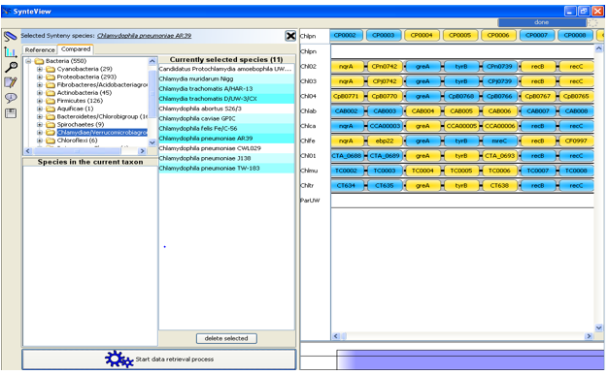
Fig. S1. Synteny blocks arrangement in SynteView panel illustrating conserved synteny between reference genome (C. pneumoniae) and compared genomes. Vertically arranged blocks indicate conserved syntons (orthologous), positive strands (blue) and negative strands (yellow).

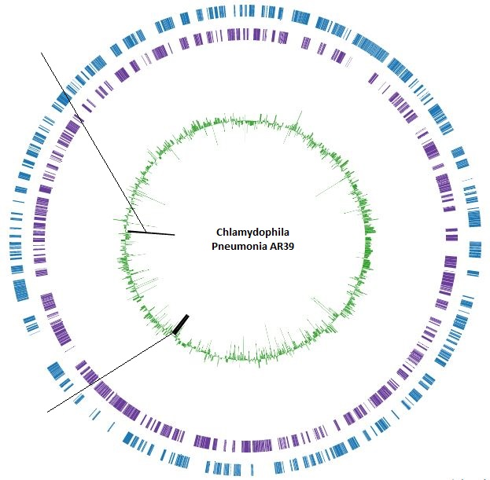
*
$
Circle 1: Genes on plus strand  Circle 2: Genes on minus strand  Circle 3: GC percentage  Darkened lines: Highlighted genes | $= ribonucleotide-diphosphate reductase subunit alpha  CP0872: Start-935902; Stop-939036  *= DNA-directed RNA polymerase subunit beta  CP0694: Start-743183; Stop-746971

Fig. S2 Illustrates the genome map of Chlamydophila Pneumoniae AR39 and its genomic features.

Table. S1 Computational prediction of protein-protein interactions among the qualified drug targets
Sl. No. | Accession number | Name | Gene code | Functional Partners | Score  (Cutoff 0.900)
1. | WP_010883336.1 | uridylate kinase | pyrH | tsf  ndk  pnp  surE  udk  cmk | 0.999  0.902  0.904  0.908  0.905  0.904
2. | WP_010883250.1 | DNA polymerase I | polA | dnaN  nrdA  dnaE  mutS  ndk  pyk | 0.987  0.999  0.987  0.910  0.930  0.921
3. | WP_010883138.1 | prolyl-tRNA Synthetase | proS | pheT  metG  lysS  leuS  ileS  argS  gltX | 0.999  0.994  0.993  0.988  0.991  0.989  0.989
4. | WP_010883113.1 | glycogen branching Enzyme | glgX | glgB  glgC  glgP  glgA  malQ  glgA | 0.999  0.999  0.992  0.999  0.956  0.999
5. | AAF38216.1 | glycosyl hydrolase family protein | glgB | glgP  glgX  malQ  glgC  glgA  pgi | 0.999  0.951  0.956  0.999  0.999  0.980
6. | WP_014517750.1 | 2-oxoglutarate dehydrogenase subunit E1 | sucA | lpdA  pdhA/pdhB  sdhB  sucC  sucD  sucC  sucD  pdhC | 0.999  0.999  0.937  0.999  0.999  0.999  0.999  0.999
7. | WP_010892051.1 | tyrosyl-tRNA Synthetase | tyrS | uvrB | 0.865
8. | WP_010882923.1 | DNA gyrase subunit B | gyrB | gyrA  gyrA_2  dnaN  topA | 0.999  0.993  0.987  0.942
9. | WP_010892079.1 | DNA gyrase subunit A | gyrA | gyrB  CP_0031  dnaN  topA  guaA | 0.999  0.998  0.988  0.962  0.934
10. | WP_010882731.1 | DNA-directed RNA polymerase subunit beta | rpoB | rpoA  nusG  fusA  rplE  pyrG  rplA  rpoD  nusA  rplL | 0.999  0.999  0.997  0.997  0.993  0.991  0.984  0.984  0.980  0.976
11. | WP_014518119.1 | Ribonucleotide diphosphate reductase subunit alpha | nrdA | nrdB  dnaN  dut  gmk  adk  tmk  guaA  trxA  ndk  polA | 0.999  0.999  0.998  0.990  0.987  0.945  0.938  0.936  0.931  0.928

Table S2. List of orthologous essential proteins classified based on their functionality
Sl.No. | Protein Accession number | Protein name | Trans-membrane helix | Subcellular localization | Signal peptide | Lipo-proteins | Toxicity
 | WP_010883361.1 | ABC transporter ATP-binding protein | N | Cytoplasmic | N | N | N
 | WP_010891960.1 | 2-dehydro-3-deoxyphosphooctonate aldolase | N | Outer Membrane | N | N | N
 | WP_010883337.1 | ribosome recycling factor | N | Cytoplasmic | N | N | N
 | WP_010883336.1 | uridylate kinase | N | Cytoplasmic | N | N | Exotoxin
 | WP_010883304.1 | DNA polymerase III subunit alpha | N | Cytoplasmic | N | N | N
 | WP_010883250.1 | DNA polymerase I | N | Cytoplasmic | N | N | Endotoxin
 | WP_010883138.1 | prolyl-tRNA synthetase | N | Cytoplasmic | N | N | Endotoxin
 | WP_010883113.1 | glycogen branching enzyme | N | Cytoplasmic | N | N | Exotoxin
 | WP_010892034.1 | ATP-dependent Clp protease ATP-binding protein | N | Cytoplasmic | N | N | N
 | WP_010883031.1 | glycosyl hydrolase family protein | N | Extracellular | N | N | Endotoxin
 | WP_010883021.1 | 2-oxoglutarate dehydrogenase subunit E1 | N | Cytoplasmic | N | N | Exotoxin
 | WP_010883016.1 | 4-hydroxy-3-methylbut-2-en-1-yl diphosphate synthase | N | Cytoplasmic | N | N | N
 | WP_010892051.1 | tyrosyl-tRNA synthetase | N | Cytoplasmic | N | N | Exotoxin
 | WP_010892069.1 | translation initiation factor IF-2 | N | Outer Membrane | N | N | N
 | WP_010892072.1 | inner membrane protein translocase component YidC | 7 | Cytoplasmic | P | P | N
 | WP_010882945.1 | ACP S-malonyltransferase | N | Cytoplasmic | N | N | N
 | WP_010882923.1 | DNA gyrase subunit B | N | Cytoplasmic | N | N | Exotoxin
 | WP_010892079.1 | DNA gyrase subunit A | N | Cytoplasmic | N | N | Exotoxin
 | WP_010892101.1 | peptide ABC transporter ATP-binding protein | N | Cytoplasmic | N | N | N
 | WP_010892116.1 | diphosphate--fructose-6-phosphate 1-phosphotransferase | N | N | N | N | N
 | WP_010882803.1 | leucyl-tRNA synthetase | N | N | N | N | N
 | WP_010882799.1 | NAD-dependent DNA ligase LigA | N | N | N | N | N
 | WP_010892126.1 | ATP-dependent Clp protease subunit B | N | N | N | N | N
 | WP_010892127.1 | glutamate-1-semialdehyde aminotransferase | N | N | N | N | N
 | WP_010892147.1 | DNA-directed RNA polymerase subunit beta | N | Cytoplasmic | N | N | Exotoxin
 | WP_010882730.1 | 50S ribosomal protein L7/L12 | N | N | N | N | N
 | WP_010882709.1 | deoxyuridine 5\'-triphosphate nucleotidohydrolase | N | N | N | N | N
 | WP_010882658.1 | aspartyl/glutamyl-tRNA amidotransferase subunit A | N | N | N | N | N
 | WP_010883693.1 | 1-deoxy-D-xylulose-5-phosphate synthase | N | N | N | N | N
 | WP_010883650.1 | 4-hydroxy-3-methylbut-2-enyl diphosphate reductase | N | N | N | N | N
 | WP_010883634.1 | cytidine/deoxycytidylate deaminase family protein | N | N | N | N | N
 | WP_010883631.1 | cell division protein FtsH | 2 | N | P | N | N
 | WP_010883618.1 | ribonucleotide-diphosphate reductase subunit beta | 1 | N | N | N | N
 | WP_010883617.1 | ribonucleotide-diphosphate reductase subunit alpha | N | Cytoplasmic | N | N | Exotoxin
 | WP_010883607.1 | succinyl-CoA synthetase subunit alpha | N | N | N | N | N
 | WP_010892213.1 | glucosamine--fructose-6-phosphate aminotransferase | N | N | N | N | N
 | WP_010883600.1 | phosphoglucosamine mutase | N | N | N | N | N
 | WP_010892221.1 | DNA mismatch repair protein MutS | N | N | N | N | N
 | WP_010883559.1 | primosome assembly protein PriA | N | N | N | N | N
 | WP_010883551.1 | 3-oxoacyl-ACP synthase II | N | N | P | P | N
 | WP_010883527.1 | alanyl-tRNA synthetase | N | N | N | N | N
 | WP_010883526.1 | transcription-repair coupling factor | N | N | N | N | N
 | WP_010883505.1 | seryl-tRNA synthetase | N | N | N | N | N
 | WP_010883485.1 | rod shape-determining protein MreB | N | N | N | N | N
 | WP_010883481.1 | ATP-dependent protease ATP-binding protein ClpX | N | N | N | N | N
 | WP_010883480.1 | poly(A) polymerase family protein | N | N | N | N | N
 | WP_010883478.1 | preprotein translocase subunit SecA | N | Cytoplasmic | N | N | Exotoxin
 | WP_010883450.1 | proline dipeptidase | N | N | N | N | N
 | WP_010883448.1 | type III secretion chaperone SycD | N | N | N | N | N
 | WP_010883438.1 | excinuclease ABC subunit B | N | N | N | N | N
 | WP_010892260.1 | phosphopyruvate hydratase | N |  | N | N | N
 | WP_010883425.1 | succinate dehydrogenase, cytochrome b558 subunit | 5 | N | N | N | N
 | WP_010883418.1 | peptidoglycan-associated lipoprotein | N | N | P | P | N
 | WP_010883409.1 | ATP-dependent helicase PcrA | N | N | N | N | N
 | WP_010883406.1 | DNA topoisomerase I/SWI domain fusion protein | N | N | N | N | N
 | WP_010883399.1 | recombinase A | N | N | N | N | N
 | WP_010892271.1 | RNA polymerase sigma factor | N | N | N | N | N
N= Nil

Table. S3 ADMET properties of the selected natural ligand molecules

Molecules | Molecular weight (MW) | TPSA  (Å²) | iLOGP | ESOL Class | GI absorption | BBB permeant | Lipinski violations | Bioavailability
CNP0064963 | 250.36 | 46.07 | 3.14 | Soluble | High | Yes | 0 | 0.55
CNP0057221 | 288.32 | 63.36 | 1.65 | Very soluble | High | No | 0 | 0.55
CNP0160386 | 297.41 | 47.53 | 2.83 | Soluble | High | Yes | 0 | 0.55
CNP0417500 | 151.14 | 60.36 | 0.99 | Very soluble | High | No | 0 | 0.85
CNP0170992 | 222.24 | 36.92 | 2.85 | Soluble | High | Yes | 0 | 0.55
CNP0361821 | 340.26 | 113.64 | 1.96 | Moderately soluble | High | No | 0 | 0.56
CNP0372149 | 179.15 | 66.43 | 1.3 | Very soluble | High | No | 0 | 0.85
CNP0108893 | 213.66 | 67.77 | 1.66 | Very soluble | High | No | 0 | 0.55
CNP0412918 | 223.27 | 58.56 | 2.09 | Soluble | High | Yes | 0 | 0.55
Cefotaxime | 455.47 | 227.05 | 2.05 | Very soluble | Low | No | 1 | 0.11

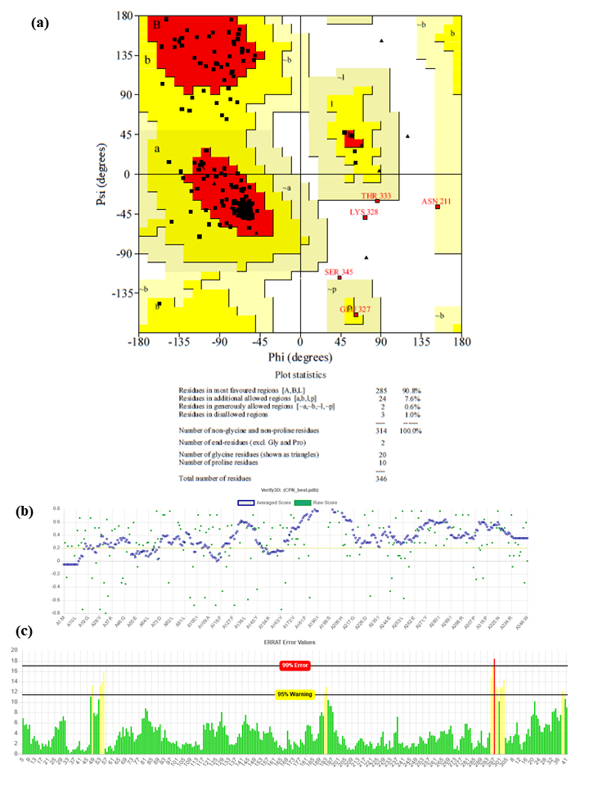
Fig. S3 Validation plots of RNR (C. pneumoniae) (a) Ramachandran plot (PROCHECK) (b) VERIFY3D plot (PASS) (c) ERRAT plot (94.97%)

