© Engineered Science Publisher LLC
Supporting Information

Thermo-Physical Properties of Graphite and Polyethylene Modified Asphalt Concrete
Mushtaq Ahmad^{1*}, Rayeh Nasr Salam Al-Dala'ien², Salmia Beddu³, Zarina Binti Itam⁴

Supplementary Results

Table. S1Bitumen Properties
Test type | Sample | Test standard | Test results | Recommended Specifications
Penetration test | 1 | AASHTO T49–93  ASTM D5, | 64 | 60–70
Penetration test | 2 | AASHTO T49–93  ASTM D5, | 67
Softening test | 1 | AASHTO T53–92  ASTM 36–89 | 54.7 | 46–56
Softening test | 2 | AASHTO T53–92  ASTM 36–89 | 53
Flash & fire | 1 | AASHTO T48  ASTM D92 | 228 and 262 | >232 °C and >246
Flash & fire | 2 | AASHTO T48  ASTM D92 |  | >246
Ductility | 1  2 | ASTMD113 | 25 ^{O}C > 100cm | >100cm

Table. S2Properties of course and Fine Aggregate
Properties | Test standards | Result
Bulk specific gravity of course granite aggregates | AASHTO T 85–91  ASTM C 127–84 | 2.71
Water absorption of coarse aggregates | AASHTO T 85–91  ASTM C 127–84 | 0.23 %
Bulk specific gravity of Fine aggregates | AASHTO T 84–93  ASTM C 128–84 | 2.64
Water absorption of fine aggregates | AASHTO T 84–93  ASTM C 128–84 | 2.49 %
Loss angele abrasion test method A,B,C | AASHTO T 96–92  ASTM C 131–81 | 22.6 %  22.3 %  21.01 %
Aggregate impact value test (30%max) | BS 812 | 15.80 %

Table. S3Mix gradation/Sieve Analysis
Sieve size (mm) | 20 | 14 | 10 | 4.75 | 2.35 | 1.20 | 0.60 | 0.15 | 0.075
Passing Ratio (% ) Gradation  Upper limit  Lower Limit | 100  100  100 | 98.70  100  92 | 75  85  70 | 48  65  45 | 37  49  29 | 29  39  18 | 21  26  24 | 17  24  9 | 5  13  3

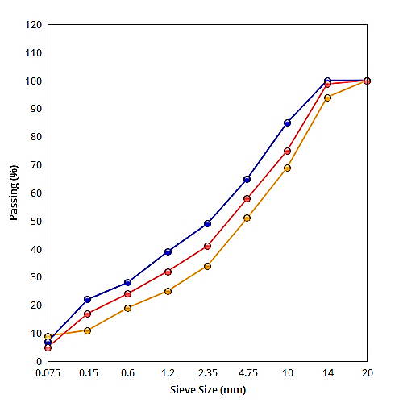
Fig. S1 otted Sieve Gradation

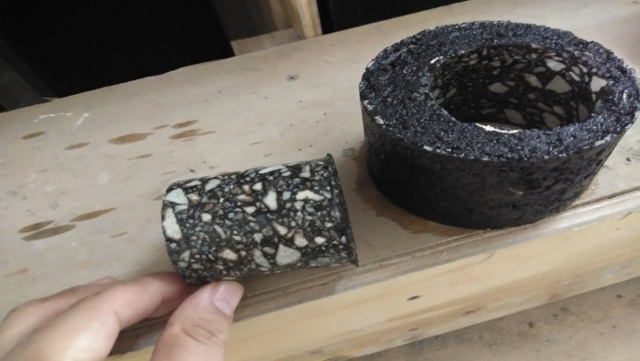
(a)
Fig. S2(a) Specimen after coring
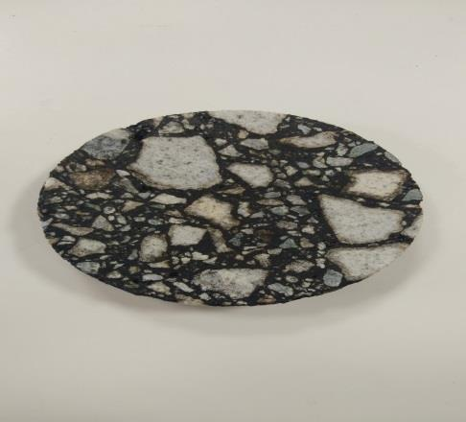
(b)

25mmx50mm

Fig. S2(b) 25mm thick and 50mm diameter specimen

