The Separation of Oil from Oil-Contaminated Soils Using Thermal Treatment

Yerbol Tileuberdi,^{1,2,*} Mukhtar Yeleuov,^{2,3} Zhazira Mukataeva¹ and Yerlan Doszhanov^{2,*}

¹ Abai Kazakh National Pedagogical University, 13 Dostyk Ave., Almaty, 050010, Kazakhstan
² Institute of Combustion Problems, 172 Bogenbai Batyr Str., Almaty, 050012, Kazakhstan
³ Engineering and Science Hub, 38 Tulebaev Str., Almaty, 050004, Kazakhstan
*Email: er.tileuberdi@gmail.com (Y. Tileuberdi), doszhanov_yerlan@mail.ru (Y. Doszhanov)

Abstract
In the paper, the oil separated from the oil-contaminated soil using thermal treatment, and the characteristics of the separated oil were studied. Thermal treatment was carried out under conditions of uniform heating from room temperature to 450 °C. The heating rate of the oil spilled on the soil was 15 °C per minute. The average duration of the thermal treatment process of the research object was 50 minutes. As the proportion of polluting oil in the soil sample obtained from the neutralization of oil spilled on the soil increases, an increase in the percentage of the separated oil (liquid product) is observed. The liquid products were subjected to physical and chemical analysis. The resulting liquid product had a water content of 7.6%. Its density is 902 kg/m³, flash point is 69 °C, and ash content is 0.18 %. It was found that the separated oil is made up of 83.72% oil and 16.28% resin fractions. Asphaltene was not seen during the group composition analysis.

Keywords: Separation; Oil-contaminated soil; Thermal treatment; Oil pollution.

Table of Contents
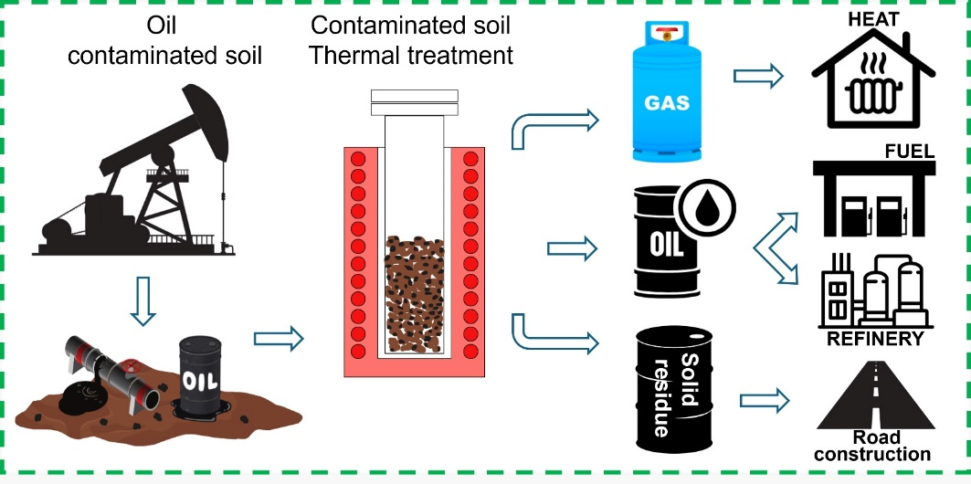

Innovative Description: The separation of oil from the oil-contaminated soil using thermal treatment is reported.

1. Introduction
A major source of energy, oil (or petroleum) powers industries, transportation, and the production of electricity, as well as a large portion of the world economy. Automobiles, trucks, buses, airplanes, and ships run on these refined oil products. Because of this, oil is necessary for international travel, trade, and mobility. Systems for heating homes and businesses also use petroleum fuels. However, oil typically generates power less frequently than other fossil fuels like coal and natural gas. Petrochemicals, bitumens, and lubricants are just a few of the industrial processes that employ oil.^{[1-7]} Despite its immense benefits, oil also poses numerous environmental risks.
Oil pollution is a significant environmental challenge arising from various human activities, including oil extraction, transportation, and refining. While these processes are economically vital, they often lead to severe environmental consequences, such as soil, water, and air contamination.^{[8-10]} Oil-contaminated soils suffer devastating impacts on their biological systems, including bacteria, fungi, and invertebrates, which are crucial for maintaining ecosystem health. Recent research indicates that even low concentrations of hydrocarbons can have toxic effects, reducing biodiversity and disrupting soil microorganisms' functional activity.^{[11-12]} Consequently, this hampers organic matter decomposition and nutrient cycling, leading to soil degradation and decreased fertility.^{[13]} Oil pollution also adversely affects vegetation. By forming an impermeable layer, oil restricts oxygen supply to plant root systems, causing stress and reducing photosynthetic activity. This diminishes ecosystem resilience and accelerates environmental degradation. Water resources are particularly vulnerable to oil spills.^{[14-16]} When oil enters water bodies, it forms a surface film that obstructs gas exchange and depletes oxygen levels essential for aquatic life. This often results in mass fish mortality and long-term disruptions to aquatic ecosystems. Oil pollution is thus a complex and multifaceted problem requiring an integrated approach to research and the development of effective remediation techniques.^{[17,18]} Continued investigation into the mechanisms of oil’s impact on ecosystems is critical for devising strategies to minimize its harmful effects and restore contaminated areas.
Oil-contaminated soils undergo cleaning or remediation using a variety of techniques, each with unique advantages and limitations.^{[19]} The primary methods include bioremediation, physicochemical techniques, and thermal treatment, which can be applied individually or in combination to achieve optimal results.^{[20-22]} Bioremediation utilizes microorganisms, such as bacteria and fungi, to degrade hydrocarbons in oil. This eco-friendly approach leverages natural processes to eliminate pollution. However, its efficiency depends on factors such as temperature, pH, oxygen levels, and nutrient availability. Additionally, some hydrocarbons are non-biodegradable, limiting this method’s applicability in specific scenarios.^{[23-25]} Physicochemical methods encompass solvent extraction, adsorption, and flocculation. These techniques often yield faster results than bioremediation, particularly for large-scale pollution.^{[26]} However, their drawbacks include high costs, the need for specialized equipment, and potential environmental risks from chemical use. Some methods may also require post-treatment to achieve complete remediation.
Thermal treatment involves heating contaminated soils to extract oil and hydrocarbons.^{[27]} Techniques like pyrolysis or thermal degradation can efficiently remove light and heavy hydrocarbons.^{[28,29]} Despite its effectiveness, thermal treatment is energy-intensive and may produce toxic by-products, necessitating a thorough evaluation of its environmental impact. The specific contamination scenario, soil properties, and environmental considerations should inform the choice of cleaning method, ensuring a balanced approach that maximizes effectiveness while minimizing costs and ecological risks.
Heat treatment is among the most effective methods for cleaning oil-contaminated soils, leveraging high temperatures to evaporate or decompose hydrocarbons.^{[30]} Technologies such as pyrolysis and thermal degradation not only remove hydrocarbons but also minimize their environmental impact. During heat treatment, volatile hydrocarbons evaporate, while heavier hydrocarbons undergo decomposition. This method is particularly useful in conditions where bioremediation or physicochemical techniques are insufficient, such as low temperatures or nutrient-deficient environments. Studies demonstrate that heat treatment can achieve hydrocarbon removal efficiencies exceeding 90%, making it a preferred choice for severe contamination.^{[31]} However, its effectiveness varies depending on soil type, hydrocarbon composition, and treatment conditions. Heat treatment may also alter hydrocarbons' physicochemical properties, potentially forming new compounds with varying toxicity.^{[32]} This necessitates comprehensive risk assessments to ensure the method's environmental safety. Thus, while heat treatment is a powerful cleaning tool, its application should be carefully planned and supplemented with environmental risk evaluations.^{[33]}
Oil recovered from contaminated soils exhibits diverse physicochemical properties influenced by soil type, contamination severity, and heat treatment conditions. Properties such as viscosity, density, hydrocarbon composition, and impurity levels are pivotal in assessing environmental and economic implications. Research shows that oil extracted from heavily polluted soils often contains elevated levels of heavy metals (e.g., lead, cadmium, mercury) and toxic compounds like polycyclic aromatic hydrocarbons (PAHs). These substances pose risks to ecosystems and human health, highlighting the need for thorough analysis.^{[34]} Heat treatment can modify hydrocarbons' molecular structures, reducing or increasing toxicity. Comprehensive chemical, environmental, and toxicological assessments of recovered oil are essential to evaluate heat treatment's efficacy and guide safe usage or disposal.^{[35]}
Heat treatment not only restores ecosystems but also offers significant economic benefits. By effectively removing oil and hydrocarbons, this method facilitates ecosystem recovery and land reuse. Environmentally, treated soils can support natural processes such as water filtration, carbon cycling, and microbial activity. This enhances soil and water quality, promoting biodiversity and ecosystem resilience. Economically, rehabilitated lands can be repurposed for agriculture, construction, or recreation, boosting local economies and supporting sustainable development. For instance, restored lands can increase food security, create jobs, and enable ecotourism. Heat treatment thus addresses oil pollution while creating opportunities for economic growth and ecosystem restoration, underscoring its role in environmental protection and sustainable development strategies.^{[36,37]} Fig. 1 shows the annual number of publications on the topic of oil-contaminated soil treatment from 2000 to 2025, indicating a clear and consistent upward trend. The data highlights a growing research interest, with the number of publications increasing steadily from fewer than 50 in the early 2000s to over 200 in the 2020s.

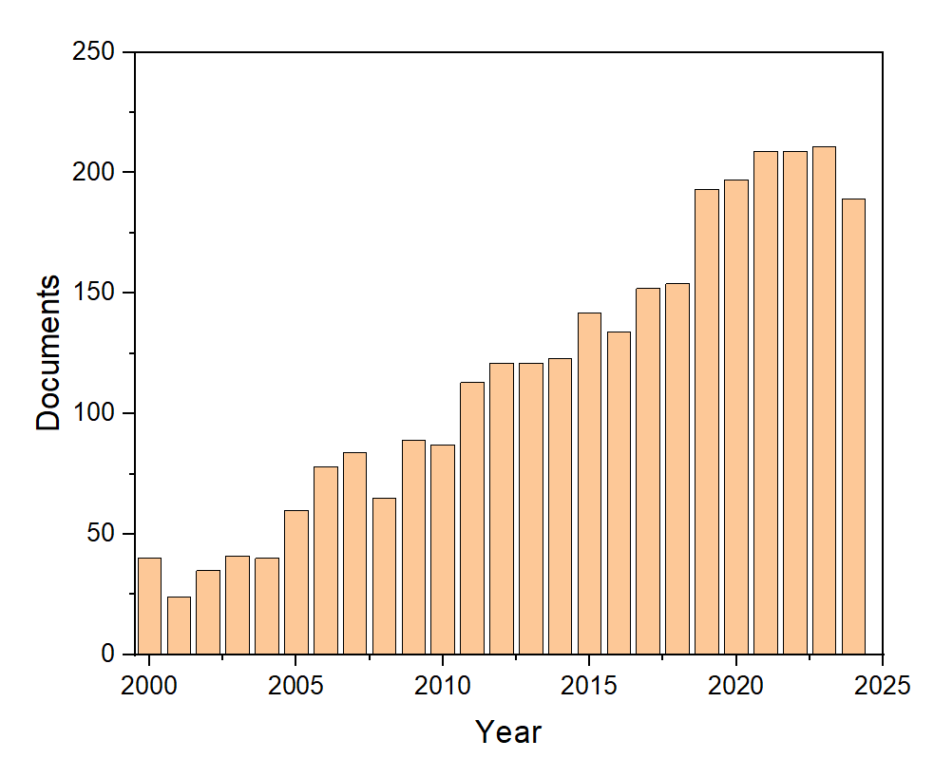
Fig. 1: Annual number of publications on oil-contaminated soil treatment (2000–2025).

This trend underscores the increasing global recognition of oil pollution as a critical environmental issue and the corresponding demand for innovative cleaning technologies. The rising volume of studies emphasizes the relevance of the current research, which contributes to this field by exploring the thermal treatment of oil-contaminated soils and characterizing the extracted oil products. In this work, we thermally treated the oil-contaminated soil in the Karazhanbas field to clean it, and we studied the characteristics of the resulting liquid product.

2. Materials and methods
2.1 Materials and sample preparation
In the paper, the soil contaminated by 10-30% Karazhanbas crude oil was used as the object of study. Karazhanbas Oil is considered the heavy oil of the Bozachi Peninsula in the Mangistau region. Currently, "Karazhanbasmunai" JSC, located in the western part of Kazakhstan, near the Caspian Sea, is one of the strategically important companies in the country. Since its establishment in 1974, the company has produced more than 50 million tons of oil.^{[4]} The study prepared 5 different samples of oil-contaminated soil. Karazhanbas crude oil contaminated the soil in varying mass percentages: 10%, 15%, 20%, 25%, and 30%. Table 1 displays these samples.

Table 1: Oil-contaminated soil samples.
Samples | OCS-10 | OCS-15 | OCS-20 | OCS-25 | OCS-30
Content of crude oil, % | 10 | 15 | 20 | 25 | 30
Photograph of samples | 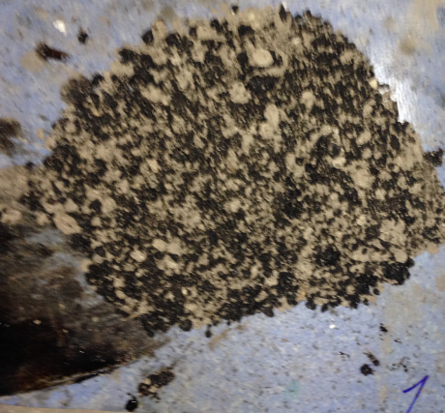 | 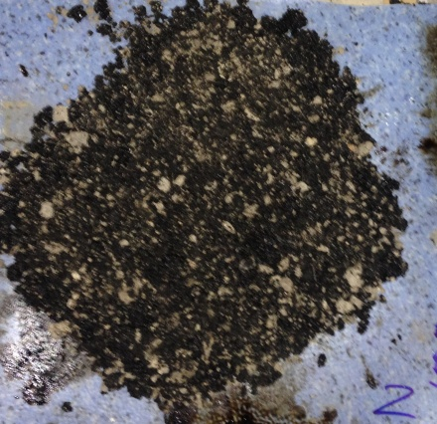 | 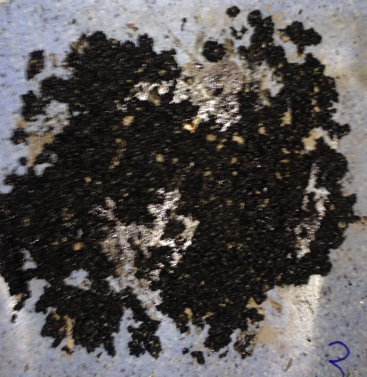 | 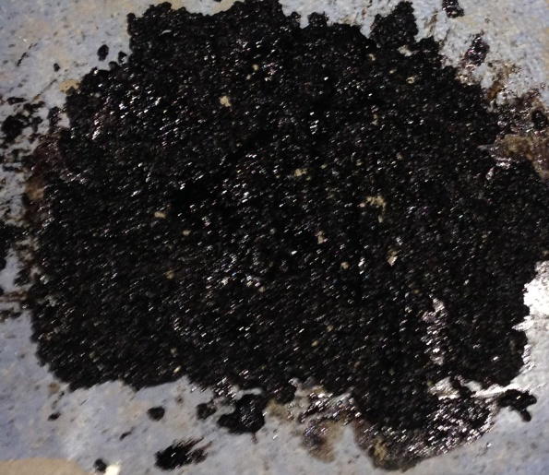 | 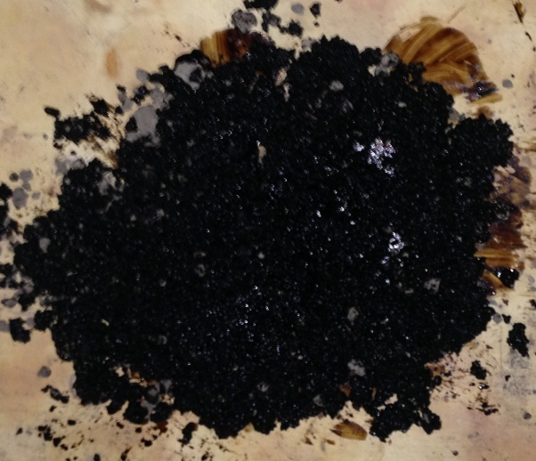

Table 1 shows that the sample OCS-10 contains 10% oil contamination, making it the sample with the lowest oil content. In this sample, we can see that part of the soil has changed to a brown color, and half of the soil color has been preserved. As the amount of oil contamination increases, its color becomes dark black. As the oil content of the last sample (OCS-30) is 30%, it completely changed the color of the soil to black.

2.2 Experimental setup for thermal treatment of oil-contaminated soil
Thermal treatment for the purpose of cleaning oil-contaminated soil was carried out under uniform heating conditions from room temperature to 450 °C. The heating rate was 15 °C per minute. During the experiment, 300 g of oil-contaminated soil was loaded into the reactor, and the furnace heating process was started. The temperature of samples and the amount of separated liquid products were measured. The heating was stopped when the temperature of the remaining raw materials in the process reactor reached a critical value, depending on the yield of the pyrolysis product. The average duration of the process was 50 minutes. To study the characteristics of the resulting liquid product as hydrocarbons, it was dewatered and fractionated. Their characteristics were studied individually using standard methods. Fig. 2 is a schematic diagram of the thermal treatment process for oil-contaminated soil. We dewatered the resultant liquid product to examine its hydrocarbon characteristics. We studied each of their characteristics individually using standard methods. as well as being fractionated and their characteristics studied individually.

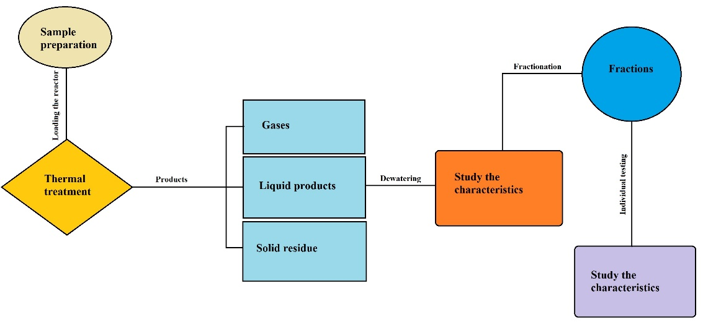
Fig. 2: Schematic diagram of the thermal treatment process for oil-contaminated soil.

2.3 Characterization of separated oil from oil-contaminated soil
The experiment used a Pycnometer to determine the density of the separated oil (hydrocarbons) samples. Distilled water was added to the weighted pycnometer until the desired volume was reached and all of the mass was weighed. Following dish cleaning, hydrocarbon was added to the oil samples, and the pycnometer was once more weighed with the oil. Finally, the density of products was determined using the following formula:
$ρ_{oil}=\frac{m_{2}-m_{0}}{m_{1}-m_{0}}∙ρ_{water}$ (1)
The ARN-LAB-11 was used to determine the figure out the fractional composition of hydrocarbons by slowly heating and condensing vapors in special containers that were kept at room temperature and pressure. The flash point of the samples was determined at АТВО-20, an apparatus for determining flash points in an open crucible. Built-in spark ignition simulates the flame of an ignition device with a diameter of 4 mm.
The Dean and Stark distillation method (ASTM D95) determined the water contents in the oil samples. Production-style oil analysis labs rarely use this test method because it is fairly cumbersome and requires a relatively large sample to ensure accuracy. Any present water vaporizes as the oil heats up. The water vapors are then condensed and collected in a graduated collection tube such that the volume of water produced by distillation can be measured as a function of the total volume of oil used.
We used the chromatographic method in a Soxhlet device to separate the group composition of the extracted oil from oil-contaminated soil. In order to allow the precipitation of insoluble components, the hydrocarbons were added to 40 times as much n-hexane as the initial quantity of the raw materials and placed in a dark, light-inaccessible location. Each step of the process removes resins, and it is performed multiple times. As a result, the precipitate appears as a brownish carbonaceous substance instead of a glossy black solid. Until no more alterations in the residue were noticed, the separation process was maintained. Activated silica gel and the Soxhlet technique were utilized to separate the maltenes in oil and resin. Silica gel was activated for four hours at 350 °C. Hexane was used to moisten activated silica gel, and manufactured maltenes were then added to the gel in a Soxhlet. The apparatus was submerged in a water bath, and 200 milliliters of hexane were used to extract oil until the flask was completely filled with hexane. Following oil extraction, the flask was swapped out by a sterile flask containing 200 milliliters of a 1:1 benzene-alcohol combination. An alcohol-benzene mixture is used to desorb silica gel's adsorbed resins. All of the solvents were removed using a rotary evaporator once the oil and resins had been separated. After that, the samples were dried at 60 ± 4 °C until their weight remained constant.
The chemical composition of oil, resin, and asphaltene fractions was identified by Fourier transform infrared spectroscopy (Spectrum-65) in cells of potassium bromide (KBr) and tablets with KBr. It is used to obtain an infrared spectrum of absorption, emission, photoconductivity, or Raman scattering of a solid, liquid, or gas. A spectrometer simultaneously collects spectral data over a wide range. The spectra in the 450–4000 cm⁻¹ range were obtained.

3. Results and discussion
In order to completely absorb oil into the soil contaminated with oil in a ratio of 10-30% and to evaporate light fractions in the oil, the samples were placed in the open air for 1 month. The thermal treatment of these samples involved measuring a specific mass of the contaminated soil, placing it in a reactor, and carrying out the furnace heating process. The liquid product that was removed from the gas and product outlet was measured and collected by a refrigerator. After the process was completed, the remaining solid residue was measured. The difference between the total mass of the sample, the mass of the obtained liquid product, and the remaining solid residue (Table 2) determined the amount of gas.

Table 2: The amount of gas, liquid product, and solid residue obtained from oil-contaminated soil.
Samples | Types of the products and their quantity
Samples | Gaseous | Liquid product | Solid residue
OCS-10 | 12.30g | 27.03g | 260.67g
OCS-10 | 4.10% | 9.01% | 86.89%
OCS-15 | 13.17g | 39.09g | 247.74g
OCS-15 | 4.39% | 13.03% | 82.58%
OCS-20 | 14.73g | 46.98g | 238.29g
OCS-20 | 4.91% | 15.66% | 79.43%
OCS-25 | 15.57g | 56.16g | 228.27g
OCS-25 | 5.19% | 18.72% | 76.09%
OCS-30 | 16.26g | 69.45g | 214.29g
OCS-30 | 5.42% | 23.15% | 71.43%

Table 2 shows the results of an increase in the percentage of liquid products obtained as the proportion of polluting oil in the soil increases. In the first sample, the liquid product was 9.01%, in the second sample, it was 13.03%, in the third sample, it was 15.66%, in the fourth sample, it reached 18.72%; and finally, in the fifth sample, it maximized to 23.15%. This indicates that as the percentage of oil products increases, the mass fraction becomes higher. The amount of gas released is 4.10% in the first sample, as well as in the fifth sample, increased to 5.42%. This indicates that the increase in gaseous products was also caused by an increase in the proportion of polluting oil in the soil in the sample.
Table 3 presents the characteristics of the liquid products produced from contaminated soil with Karazhanbas crude oil. According to the quantitative data, the amount of liquid products and gas that initially polluted the soil exceeded the amount of crude oil that was added. This is because very small amounts of organic impurities and water in the soil are added to the obtained hydrocarbon products during thermal processing.
As the temperature decreases, the solubility of oil in water decreases, and water can form and separate water-in-oil emulsions in the form of dispersed particles. In a monodisperse emulsion, water can reach up to 70%. In real conditions, water-in-oil emulsions are polydisperse. In oil-collecting, dewatering, and desalination plants, the size of water globules ranges from 3 to 10 microns. These parameters depend on the hydrodynamic and other conditions of oil production, as well as the degree of wetting in the formation.
Another innovative method is the use of superhydrophobic materials for oil-water separation. Superhydrophobicity refers to a surface property where materials repel water to an extreme degree, with water contact angles exceeding 150° and can be applied in different fields, including oil separation.^{[38-40]} This unique characteristic, inspired by natural surfaces like lotus leaves, allows water droplets to bead up and roll off while selectively absorbing oil. These properties make superhydrophobic materials highly effective in addressing oil spills, industrial wastewater treatment, and other environmental challenges. Furthermore, some researchers have focused on advancing these materials for practical applications. Zhu et al.^{[41]} demonstrated that superhydrophobic materials, such as copper mesh and sponge, can efficiently separate oil from water and be reused multiple times, making them a sustainable solution for large-scale use. Similarly, Rasouli et al.^{[42]} reviewed superhydrophobic and superoleophilic membranes, which not only achieve oil removal efficiencies of over 99% but also exhibit durability and stability under various conditions.
To confirm the absence of water, heat the oil product under study (excluding oil and liquid petroleum fuels, as per GOST 26432) in an oil bath to a temperature of up to 150 degrees. The absence of hissing indicates no water in the oil. As a result of the testing method of Dean and Stark distillation, the water content in the oil-contaminated soil was 7.6% by mass. Therefore, the water contained in the liquid products was separated and further analyzed using standard methods as oil products.
Because it indicates how easily an oil or oil product can ignite under specific circumstances, the flash point is significant. The lowest temperature at which oil generates enough vapor to combine with air close to the liquid's surface to form a combustible mixture is known as the oil's flash point. This is a crucial characteristic for assessing the oil's handling and safety.
Typically, oils have flash points that range from 30 to 200 °C. The flash point of pyrolyzed oil indicated 69 °C, suggesting that it likely contains lighter hydrocarbons such as kerosene-like compounds and naphtha. Pyrolysis processes heat the complex organic materials of soil-contaminated oil in a low-oxygen environment, breaking them down into smaller or lighter hydrocarbon compounds like aliphatic hydrocarbons. They are more volatile and easily vaporize.

Table 3: Characteristics of the liquid products produced from contaminated soil with the Karazhanbas crude oil.
Characteristics of the liquid products | Water content | Density | Flash point | Ash content
Numeric values | 7.6% | 902 kg/m³ | 69 °C | 0.18%

The ash content of the liquid products produced from contaminated soil with the Karazhanbas crude oil was 0.18%. Hydrocarbons are released as gases during pyrolysis and condense back into liquids, but the solid residue often retains the ash content. High temperatures during pyrolysis decompose heavy oil, separating and condensing the light fractions of hydrocarbons. These gases, which are the light fractions of the oil, evaporate and do not form part of the ash. The liquid pyrolysis oil that has condensed after the gases (i.e., the liquid product after pyrolysis) contains light hydrocarbons, but the heavy fractions and mineral impurities may still remain in the liquid state. During pyrolysis, the separation of heavy hydrocarbons and mineral impurities into solids may result in a slightly lower ash content in the liquid pyrolysis oil compared to the original oil.
The density of the liquid products produced from oil-contaminated soil was 902 kg/m³. Fig. 3 compares this density with that of the original Karazhanbas crude oil and fractions of thermal treatment products. These were the products obtained from the thermal treatment of oil-contaminated soil, the fraction up to 180 °C from the initial boiling point, the fraction up to 180-250 °C, and the product remaining after 250 °C.

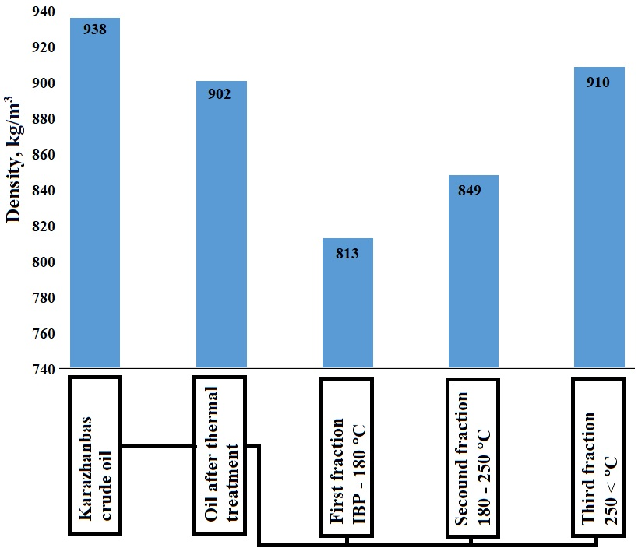
Fig. 3: Comparison density of original Karazhanbas crude oil and thermal treatment products.

According to the data in the figure, the density of the liquid product obtained from the oil-contaminated soil was lower than that of the base crude oil. This is due to the thermal treatment, which provides heavy hydrocarbons for the thermal destruction of heavy fractions. According to the results of further fractionation, the density of the fraction from the initial boiling point to 180 °C was 813 kg/m³. This fraction density corresponds to light oil products. The density of the fraction between 180-250 °C is heavier than the first fraction, it was 849 kg/m³. This showed that the fraction obtained at a boiling point after 250 °C was heavier than the two fractions, and it reached 910 kg/m³. This is due to the residue that remained after the extraction of the first and second fractions. Even so, its density is not much different from the base oil. It is slightly heavier.
The group composition of the liquid product obtained from the soil contaminated with the Karazhanbas oil field was studied in comparison. Table 4 displays the results. Asphaltene was not detected in the product obtained after thermal treatment of the oil spilled into the soil. In the thermal cracking process, hydrocarbon generates free radicals, which leads to the formation of light gases and coke products. Regarding the thermal destruction of heavy hydrocarbons, some complex bonds were broken, that is, unsaturated hydrocarbons began to become slightly saturated.^{[43-45]} Accordingly, we can see that the amount of oil increased while the amount of resin decreased.
The color of these oil fractions is light brown, and they tend to have a relatively clean and light appearance. They consist mainly of hydrocarbons with low molecular weight, which are lighter and more volatile. Usually, the exact color may vary depending on the sources and the refining process. Compared to lighter oils, resins have a higher molecular weight and include more complex, aromatic, and polar chemicals. The resins contain some degree of ring-structured aromaticity, which contributed to their darker color. Asphaltenes are solid, high-density, non-volatile, and very dark in color due to their complex molecular structure. Metal impurities like nickel and vanadium, along with aromatic rings, accentuate the black color of asphaltenes. These colors aid in comprehending the properties and makeup of crude oil, impacting its viscosity, general quality, and refining process.

Table 4: Group composition of liquid products in comparison to Karazhanbas crude oil.
Group composition | Oil fractions,% | Resin fractions, % | Asphaltene fractions, %
Karazhanbas crude oil | 68.85 | 21.32 | 5.94
Appearance of separated fractions | 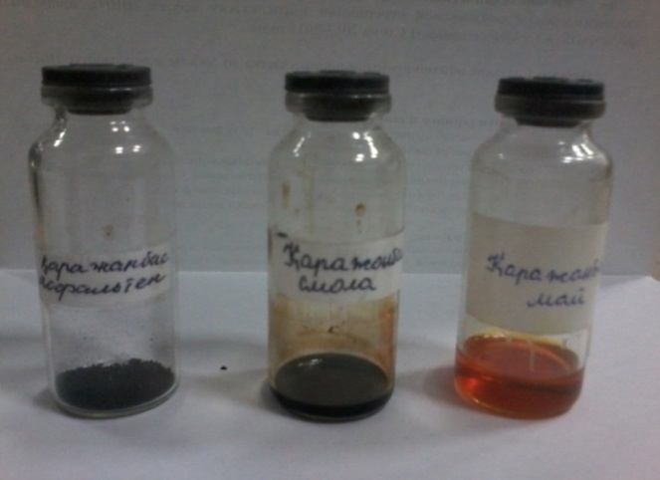
Liquid products from oil-contaminated soil | 87.92 | 10.29 | 0
Appearance of separated fractions | 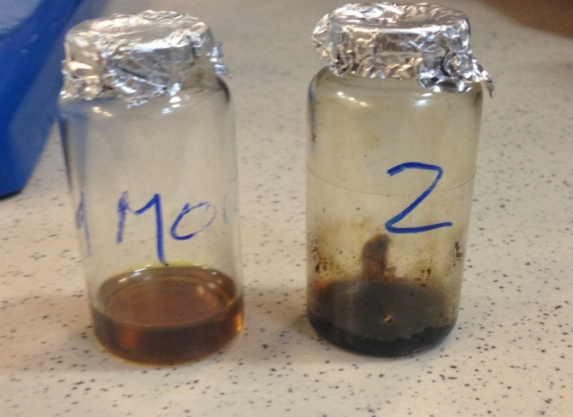 |  | -

The chemical composition of the liquid product of oil-contaminated soil was studied by IR spectroscopy. In the IR spectrum of the oil fraction of the liquid product, the following peaks were observed: 2954.06 cm⁻¹, 2854.95 cm⁻¹, 1603.97 cm⁻¹, 1459.48 cm⁻¹, 1377.04 cm⁻¹, 965.44 cm⁻¹, 811.69 cm⁻¹, 743.99 cm⁻¹. They are presented in Fig. 4.
There are two peaks: one at 2954.06 cm⁻¹ shows the asymmetric stretching of the C-H bond in methyl groups (–CH₃), and the other at 2854.95 cm⁻¹ shows the symmetric stretching of the C-H bond in methylene groups (–CH₂). These peaks also indicate the presence of alkyl groups and long-chain hydrocarbons. They are common in oils and organic contaminants. The peak 1603.97 cm⁻¹ is associated with C=C stretching vibrations in aromatic compounds such as benzene rings. And they can associate conjugated alkenes. This peak indicates the presence of aromatic hydrocarbons and unsaturated compounds in the oil fraction.
There are two peaks at 1459.48 cm⁻¹ and 1377.04 cm⁻¹. They are linked to C-H scissoring vibrations in methylene groups (-CH₂-) and methyl groups (-CH₀). They are part of the alkyl chains in hydrocarbons and aliphatic hydrocarbons. The peak around 965.44 cm⁻¹ corresponded to C-H out-of-plane bending vibrations in aromatic hydrocarbons. 743.99 cm⁻¹ and 811.69 cm⁻¹ peaks are represented by C-H out-of-plane bending vibrations in aromatic compounds with a substitution pattern. This indicates the presence of more aromatic hydrocarbons in the oil.

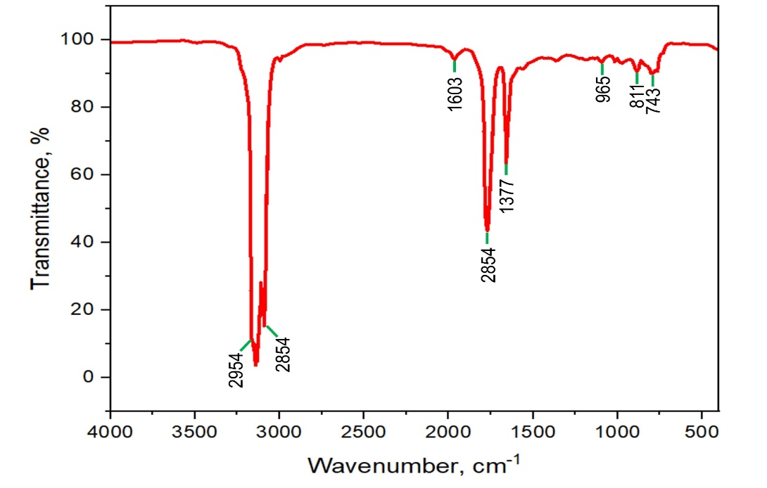
Fig. 4: Oil fraction of liquid product separated from oil-contaminated soil.

The resin fraction of the liquid product, which was separated from oil-contaminated soil using a thermal method, was also analyzed by infrared spectroscopy. Fig. 5 reveals a significantly more complex composition of compounds in the resin fractions compared to the oil fraction. At the peak of 3311.07 cm⁻¹ is associated with the stretching vibration of hydroxyl groups (–OH). They are often present in resins and other organic materials. The peak at 2854.54 cm⁻¹ corresponds to C-H stretching vibrations of saturated hydrocarbons, such as alkyl groups. They might indicate the presence of methyl (–CH₃) or methylene (–CH₂) groups in the resin. The strong absorption at 1705.36 cm⁻¹ is characteristic of the stretching vibration of the carbonyl group (C=O). They could come from aldehydes, carboxylic acids, ketones, and esters. They suggested oxidation or decomposition of organic material during the thermal treatment of oil-contaminated soil. The peak at 1603.92 cm⁻¹ is thought to be the stretching vibration of carbon-carbon double bonds (C=C) in systems that are conjugated, most likely aromatic rings. The analysis concluded that the resin contained aromatic compounds, which are commonly found in products of thermal degradation processes. The peak at 1456.34 cm⁻¹ associated with the bending vibration of the C-H bonds in methylene groups (–CH₂), and 1377.46 cm⁻¹ bending vibration (rocking) of methyl groups (–CH₃). These can be found in aliphatic chains, hydrocarbon compounds, and resinous materials. The two peaks at 1277.99 cm⁻¹ and 1034.47 cm⁻¹ show that ether (C–O–C) and alcohol (C–OH) functional groups are present. These peaks indicate the presence of oxygen-containing structures in resins and organic materials.

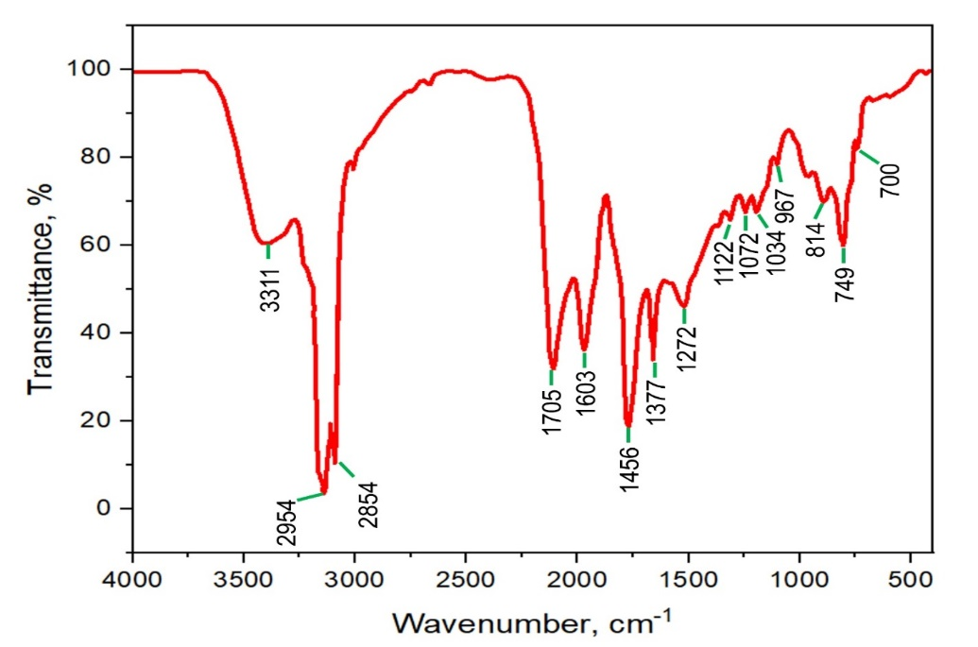
Fig. 5: Resin fraction of liquid product separated from oil-contaminated soil.

Additionally, the picture displays similar compounds that repeat themselves. The peaks at 1122.01 cm and 1072.92 cm correspond to the C-O stretching of alcohols, phenols, or ethers. They are commonly contained in resins or products derived from thermal degradation. The peaks at 814.58 cm⁻¹, 744.42 cm⁻¹ and 700.15 cm⁻¹ correspond to out-of-plane bending of C-H bonds in aromatic compounds. Monosubstituted and disubstituted aromatic rings are typically associated with these peaks.
Many countries, including Kazakhstan, are currently developing their oil industries. Oil is our main export product. However, its extraction, transportation, purification, and processing are impossible without waste generation. Therefore, the disposal of such polluting waste is an urgent problem. Thermal decomposition of waste containing hydrocarbons forms gas, liquid products and solid residue (Fig. 6).

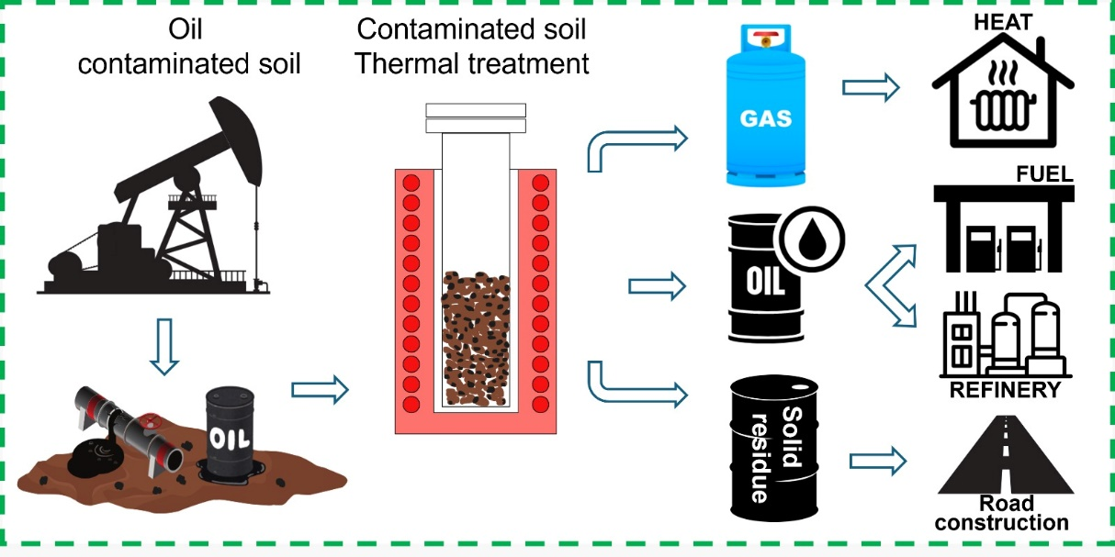
Fig. 6: Thermal treatment for oil-contaminated soil.

Separated oil from oil-contaminated soil also known as liquid pyrolysis product, pyrolysis oil, and pyrocarbon. You can use these products for both commercial and industrial purposes. This product will bring additional income, or you can use the obtained raw materials in your work to reduce costs. In addition, the residue after thermal treatment of oil-contaminated soil can be used to produce high-quality building materials.
Regarding the results, it can be concluded that the thermal treatment method for waste processing is completely environmentally friendly. The method allows to maximally extract hydrocarbons from oil-contaminated soil and minimize residual waste. This is a truly effective, safe, and relatively inexpensive method.

4. Conclusion
The scientific article talks about how to clean up the waste that contains oil and get oil products out of it by heating carbon-containing parts of raw materials to 450 °C and breaking them down thermally. Five different amounts (10-30%) of Karazhanbas oil-contaminated soil were studied. The more oil spilled into the soil, the more liquid product was obtained. Thermal treatment transfers all the water in the contaminated soil into liquid hydrocarbons, resulting in a water content of 7.6%. A flash point of 69 °C for the separated oil reflects the presence of lighter, more volatile hydrocarbons, which make it easier to ignite and more prone to forming flammable mixtures at moderate temperatures. After the thermal treatment process, the liquid oil had an ash content of 0.18%. This change happens because heavy parts evaporate during heat treatment, and some mineral impurities turn into solid residues.
According to the infrared spectrum of the oil fraction that was heated to separate it from the oil-contaminated soil, the oil is a mix of alkyl (alkane) and aromatic hydrocarbons. The peaks at higher wavenumbers (2954 cm⁻³ and 2854 cm⁻³) show that long-chain alkanes or alkyl groups are present. The peaks at lower wavenumbers (1600 cm⁻³ and below) show that aromatic compounds (like benzene rings) and unsaturated hydrocarbons are present. The IR spectrum shows that the resin fraction has a mix of aliphatic (C–H stretching), aromatic (C=C, C–H bending), and oxygenated organic compounds (–OH, C=O, and C–O). These are typical of products that are made by heating oil-contaminated soils. Waste containing hydrocarbons undergoes thermal breakdown to produce a liquid pyrolysis product. These items are suitable for both industrial and commercial applications. Consequently, this product will generate more revenue. Based on the findings, it can be said that the thermal treatment method is not harmful to the environment at all for the cleaning oil-contaminated solids. This is a safe, reasonably priced, and genuinely effective approach.

Acknowledgments
This work was supported by the Abai Kazakh National Pedagogical University (Agreement № 61, from 28.06.2024, Project on "Design and manufacture of a mobile reactor for oil separation from sand-soil rocks").

Conflict of Interest
There is no conflict of interest.

Supporting Information
Not applicable.

References
[1] D. Karimov, Z. Toktarbay, Enhanced oil recovery: techniques, strategies, and advances, ES Materials & Manufacturing, 2023, 23, 1005, doi: 10.30919/esmm1005.
[2] N. K. Nadirov, High-viscosity oil and natural bitumen: in 5 volumes, 2001.
[3] D. K. Banerjee, Oil sands, heavy oil and bitumen, 2012.
[4] Y. Tileuberdi, Y. Ongarbayev, Y. Imanbayev, A. Yermekova, F. Behrendt, A. Ismailova, K. Zhanbekov, A. Seilkhan, Z. Mansurov, Studying characteristics of natural bitumen of oil sand with comparison to heavy crude oil, ES Materials & Manufacturing, 2023, 22, 1035, doi: 10.30919/esmm1035.
[5] K. Gabdullin, Y. Bek Ali, N. Aldabek, Oil Prices Impact on Energy Policy of Kazakhstan, International Journal of Social, Human Science and Engineering, 2012, 6, 1-4.
[6] S. M. Ozdoyev, N. Tileuberdi, The geological prerequisites for increasing oil production at the North Karamandybas field, News of the National Academy of Sciences of the Republic of Kazakhstan, Series of Geology and Technical Sciences, 2017, 4, 276-280.
[7], N. Tileuberdi, M. Mashrapova, Z. Toktarbay, A review on nitrogen flooding for enhanced oil recovery, ES Materials & Manufacturing, 2023, 22, 968, doi: 10.30919/esmm968.
[8] Y. O. Doszhanov, Y. K. Ongarbaev, Z. A. Mansurov, A. A. Zhubanova, M. Hofrichter, Bioremedation of oil and oil products bacterial species of the genus pseudomonas, Eurasian Chemico-Technological Journal, 2015, 12, 157, doi: 10.18321/ectj39.
[9] G. Baitasheva, A. Mussina, G. Medeuova, A. Kuandykova, E. Imanova, A. Sartayeva, K. Zhamanbayeva, A. Umbetulla, Dynamics of germination of vegetable seeds when using dimethyl (1-hydroxy-1-phenylethyl) phosphanate as an accelerator, Caspian Journal of Environmental Sciences, 2024, 22, 1-8, doi:10.22124/cjes.2024.8138.
[10] K. Sharma, G. Shah, K. Singhal, V. Soni, Comprehensive insights into the impact of oil pollution on the environment, Regional Studies in Marine Science, 2024, 74, 103516, doi: 10.1016/j.rsma.2024.103516
[11] J. J. Dos Santos, L. T. Maranho, Rhizospheric microorganisms as a solution for the recovery of soils contaminated by petroleum: A review, Journal of Environmental Management, 2018, 210, 104-113, doi: 10.1016/j.jenvman.2018.01.015.
[12] L. Musilova, J. Ridl, M. Polivkova, T. Macek, O. Uhlik, Effects of secondary plant metabolites on microbial populations: changes in community structure and metabolic activity in contaminated environments, International Journal of Molecular Sciences, 2016, 17, 1205, doi: 10.3390/ijms17081205.
[13] S. Liu, K. Zamanian, P. M. Schleuss, M. Zarebanadkouki, Y. Kuzyakov, Degradation of Tibetan grasslands: Consequences for carbon and nutrient cycles, Agriculture, Ecosystems & Environment, 2018, 252, 93-104, doi: 10.1016/j.agee.2017.10.011.
[14] Z. Asif, Z. Chen, C. An, J. Dong, Environmental impacts and challenges associated with oil spills on shorelines, Journal of Marine Science and Engineering, 2022, 10, 762, doi: 10.3390/jmse10060762.
[15] H. Singh, N. Bhardwaj, S. K. Arya, M. Khatri, Environmental impacts of oil spills and their remediation by magnetic nanomaterials, Environmental Nanotechnology, Monitoring & Management, 2020, 14, 100305, doi: 10.1016/j.enmm.2020.100305.
[16] Y. Lu, J. Yuan, X. Lu, C. Su, Y. Zhang, C. Wang, X. Cao, Q. Li, J. Su, V. Ittekkot, R. A. Garbutt, S. Bush, S. Fletcher, T. Wagey, A. Kachur, N. Sweijd, Major threats of pollution and climate change to global coastal ecosystems and enhanced management for sustainability, Environmental Pollution, 2018, 239, 670-680, doi: 10.1016/j.envpol.2018.04.016.
[17] Y. O. Doszhanov, Y. K. Ongarbaev, M. Hofrichter, A. A. Zhubanova, Z. A. Mansurov, The using of pseudomonas cells for bioremediation of oil contaminating soils, Eurasian Chemico-Technological Journal, 2009, 11, 69-75, doi: 10.18321/ectj445.
[18] Z. Mansurov, Y. O. Doszhanov, Y. K. Ongarbaev, N. S. Akimbekov, A. A. Zhubanova, The evaluation of process of bioremediation of oil-polluted soils by different strains of pseudomonas, Advanced Materials Research, 2013, 647, 363-367, doi: 10.4028/www.scientific.net/amr.647.363.
[19] U. Michael-Igolima, S. J. Abbey, A. O. Ifelebuegu, A systematic review on the effectiveness of remediation methods for oil contaminated soils, Environmental Advances, 2022, 9, 100319, doi: 10.1016/j.envadv.2022.100319.
[20] Q. Wang, S. Guo, M. Ali, X. Song, Z. Tang, Z. Zhang, M. Zhang, Y. Luo, Thermally enhanced bioremediation: A review of the fundamentals and applications in soil and groundwater remediation, Journal of Hazardous Materials, 2022, 433, 128749, doi: 10.1016/j.jhazmat.2022.128749.
[21] S. Kuppusamy, N. R. Maddela, M. Megharaj, K. Venkateswarlu, Ecological impacts of total petroleum hydrocarbons, Total Petroleum Hydrocarbons, 2019, 95-138, doi: 10.1007/978-3-030-24035-6_5.
[22] Y. O. Doszhanov, Z. A. Mansurov, Y. K. Ongarbaev, Y. Tileuberdi, A. A. Zhubanova, The study of biodegradation of diesel fuels by different strains of Pseudomonas, Applied Mechanics and Materials, 2013, 467, 12-15, doi: 10.4028/www.scientific.net/amm.467.12.
[23] S. K. Bhatia, H.-S. Joo, Y.-H. Yang, Biowaste-to-bioenergy using biological methods–A mini-review, Energy Conversion and Management, 2018, 177, 640-660, doi: 10.1016/j.enconman.2018.09.090.
[24] Y. Ongarbayev, M. Baigulbayeva, Y. Tileuberdi, K. Zhumakhan, Sorption of oil by mechanochemicaly activated shungite, Rudarsko-Geološko-Naftni Zbornik, 2022, 37, 17-26, doi: 10.17794/rgn.2022.4.2.
[25] X. Chen, Q. Che, S. Li, Z. Liu, H. Yang, Y. Chen, X. Wang, J. Shao, H. Chen, Recent developments in lignocellulosic biomass catalytic fast pyrolysis: Strategies for the optimization of bio-oil quality and yield, Fuel Processing Technology, 2019, 196, 106180, doi: 10.1016/j.fuproc.2019.106180.
[26] A. Sabitov, M. Atamanov, O. Doszhanov, K. Saurykova, K. Tazhu, A. Kerimkulova, A. Orazbayev, Y. Doszhanov, Surface characteristics of activated carbon sorbents obtained from biomass for cleaning oil-contaminated soils, Molecules, 2024, 29, 3786, doi: 10.3390/molecules29163786.
[27] Y. Doszhanov, A. Sabitov, Z. Mansurov, G. Kaiyrmanova, Bioremediation of oil-contaminated soils of the zhanazhol deposit from west Kazakhstan by pseudomonas mendocina H-3, Applied and Environmental Soil Science, 2024, 2024, 8510911, doi: 10.1155/2024/8510911.
[28] L. Mohammadi, A. Rahdar, E. Bazrafshan, H. Dahmardeh, M. Abu Bin Hasan Susan, G. Z. Kyzas, Petroleum hydrocarbon removal from wastewaters: a review, Processes, 2020, 8, 447, doi: 10.3390/pr8040447.
[29] L. Beesley, E. Moreno-Jiménez, J. L. Gomez-Eyles, E. Harris, B. Robinson, T. Sizmur, A review of biochars' potential role in the remediation, revegetation and restoration of contaminated soils, Environmental Pollution, 2011, 159, 3269-3282, doi: 10.1016/j.envpol.2011.07.023.
[30] K. Sharma, G. Shah, H. Singh, U. Bhatt, K. Singhal, V. Soni, Advancements in natural remediation management techniques for oil spills: Challenges, innovations, and future directions, Environmental Pollution and Management, 2024, 1, 128-146, doi: 10.1016/j.epm.2024.08.003.
[31] J. E. Vidonish, K. Zygourakis, C. A. Masiello, G. Sabadell, P. J. J. Alvarez, Thermal treatment of hydrocarbon-impacted soils: a review of technology innovation for sustainable remediation, Engineering, 2016, 2, 426-437, doi: 10.1016/J.ENG.2016.04.005.
[32] A. B. Patel, S. Shaikh, K. R. Jain, C. Desai, D. Madamwar, Polycyclic aromatic hydrocarbons: sources, toxicity, and remediation approaches, Frontiers in Microbiology, 2020, 11, 562813, doi: 10.3389/fmicb.2020.562813.
[33] \. Kazakh-British University, S. Turganbay, O. B. O. Road, S. Aidarova, S. Kumargaliyeva, D. Argimbayev, A. Sabitov, Z. Iskakbayeva, M. Lyu, N. Ibragimova, G. Turganbay, Mechanochemical synthesis of hydrophilic sulfur nanoparticles in aqueous surfactant solutions and their antibacterial activity and acute toxicity in mice, ES Materials & Manufacturing, 2024, 23, 574-598, doi: 10.30919/esmm1020.
[34] W. Gwenzi, L. Mangori, C. Danha, N. Chaukura, N. Dunjana, E. Sanganyado, Sources, behavior, and environmental and human health risks of high-technology rare earth elements as emerging contaminants, Science of the Total Environment, 2018, 636, 299-313, doi: 10.1016/j.scitotenv.2018.04.235.
[35] C. Campanale, C. Massarelli, I. Savino, V. Locaputo, V. F. Uricchio, A detailed review study on potential effects of microplastics and additives of concern on human health, International Journal of Environmental Research and Public Health, 2020, 17, 1212, doi: 10.3390/ijerph17041212.
[36] N. Hassibi, Y. Quiring, V. Carré, F. Aubriet, L. Vernex-Loset, G. Mauviel, V. Burklé-Vitzthum, Analysis and control of products obtained from pyrolysis of polypropylene using a reflux semi-batch reactor and GC-MS/FID and FT-ICR MS, Journal of Analytical and Applied Pyrolysis, 2023, 169, 105826, doi: 10.1016/j.jaap.2022.105826.
[37] J. Escalante, W.-H. Chen, M. Tabatabaei, A. T. Hoang, E. E. Kwon, K. A. Lin, A. Saravanakumar, Pyrolysis of lignocellulosic, algal, plastic, and other biomass wastes for biofuel production and circular bioeconomy: A review of thermogravimetric analysis (TGA) approach, Renewable and Sustainable Energy Reviews, 2022, 169, 112914, doi: 10.1016/j.rser.2022.112914.
[38] Z. Suiindik, E. Adotey, N. Kydyrbay, M. Zhazitov, N. Nuraje, O. Toktarbaiuly, Formulating superhydrophobic coatings with silane for microfiber applications, Eurasian Chemico-Technological Journal, 2024, 26, 53-60, doi:10.18321/ectj1607.
[39] N. Kydyrbay, E. Adotey, M. Zhazitov, Z. Suiindik, Z. Toktarbay, N. Nuraje, O. Toktarbaiuly, Enhancing road durability and safety: a study on silica-based superhydrophobic coating for cement surfaces in road construction, Engineered Science, 2024, 30, 1221, doi:10.30919/es1221.
[40] O. Toktarbaiuly, A. Kurbanova, G. Imekova, M. Abutalip, Zh. Toktarbay, Desert water saving and transportation for enhanced oil recovery: bridging the gap for sustainable oil recovery, Eurasian Chemico-Technological Journal, 2023, 25, 193-200, doi: 10.18321/ectj1522.
[41] X. Zhu, Z. Zhang, B. Ge, X. Men, X. Zhou, & Q. Xue, A versatile approach to produce superhydrophobic materials used for oil–water separation, Journal of colloid and interface science, 2014, 432, 105-108, doi:10.1016/j.jcis.2014.06.056.
[42] S. Rasouli, N. Rezaei, H. Hamedi, S. Zendehboudi, X. Duan, Superhydrophobic and superoleophilic membranes for oil-water separation application: a comprehensive review, Materials & Design, 2021, 204, 109599, doi: 10.1016/j.matdes.2021.109599.
[43] Y. Imanbayev, Y. Tileuberdi, Y. Ongarbayev, Z. Mansurov, A. Batyrbayev, Y. Akkazin, E. Krivtsov, A. Golovko, S. Rudyk, Changing the structure of resin-asphaltenes molecules in cracking, Eurasian Chemico-Technological Journal, 2017, 19, 147, doi: 10.18321/ectj645.
[44] Y. Imanbayev, Y. Ongarbayev, Y. Tileuberdi, E. Krivtsov, A. Golovko, Z. Mansurov, High temperature transformation of tar-asphaltene components of oil sand bitumen, Journal of the Serbian Chemical Society, 2017, 82, 1063-1073, doi: 10.2298/jsc161126069i.
[45] Y. Ongarbayev, A. Golovko, E. Krivtsov, E. Tileuberdi, Y. Imanbayev, B. Tuleutayev, Z. Mansurov, Thermocatalytic cracking of Kazakhstan’s natural bitumen, Studia UBB Chemia, 2014, 59, 57-64.
Publisher’s Note: Engineered Science Publisher remains neutral with regard to jurisdictional claims in published maps and institutional affiliations.

Open Access
For CC-BY
This article is licensed under a Creative CommonsAttribution4.0International License, which permits use, sharing, adaptation, distribution and reproduction in any medium or format, as long as you give appropriate credit to the original author(s) and the source, provide a link to the Creative Commons licence, and indicate if changes were made. The images or other third-party material in this article are included in the article’s Creative Commons licence, unless indicated otherwise in a credit line to the material. If material is not included in the article’s Creative Commons licence and your intended use is not permitted by statutory regulation or exceeds the permitted use, you will need to obtain permission directly from the copyright holder. To view a copy of this licence, visit http://creativecommons.org/licenses/by/4.0/.
©The Author(s) 2025.

(Or)

For CC-BY-NC-ND
This article is licensed under a Creative Commons Attribution-NonCommercial-NoDerivatives 4.0 International License, which permits any non-commercial use, sharing, distribution and reproduction in any medium or format, as long as you give appropriate credit to the original author(s) and the source, provide a link to the Creative Commons licence, and indicate if you modified the licensed material. You do not have permission under this licence to share adapted material derived from this article or parts of it. The images or other third-party material in this article are included in the article’s Creative Commons licence, unless indicated otherwise in a credit line to the material. If material is not included in the article’s Creative Commons licence and your intended use is not permitted by statutory regulation or exceeds the permitted use, you will need to obtain permission directly from the copyright holder. To view a copy of this licence, visit https://creativecommons.org/licenses/by-nc-nd/4.0/
©The Author(s) 2025.

